**2013-2014 EDUCATION YEAR SEVİN FATİH PRIMARY SCHOOL THE 2nd TERM**

**THE 1st ENGLISH WRITTEN EXAM FOR THE 8TH GRADES**

**Name Surname : Number : Mark:**

**A)Read the text and answer the questions.(5x3=15)**

***GALILEO***

Galileo was born in [Pisa](http://en.wikipedia.org/wiki/Pisa),Italy in 1564.He was one of the five sons of the family.Galileo was always interested in science,espically in maths.He studied medicine at the University of Pisa in 1581.He also studied astronomy and he published a small book about the Sun and the stars in 1586.He made researches about the Earth’s shape and space for years.In 1610, he developed a new telescope and in 1615, he discovered that the Earth was turning around the Sun.Then,people thought he was crazy because at that time people believed the Sun was turning around the Earth.Also,people thought the Earth flat,not round.The Church got very angry with Galileo and they put him into prison and they wanted Galileo to apologize.In 1638,he got blind and he couldn’t see anymore.He died of a heart attack in 1642.

1.Where was Galileo born? 2.What did he study at the University of Pisa? 3. Did he publish a book?

………………………………. ……………………………………………….. ……………………………

4.What did he discover in 1615? 5. Could he see in 1638?

………………………………………… …………………………………

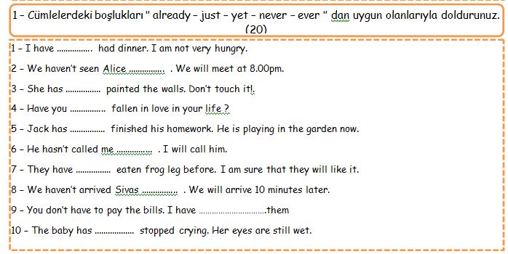

**B)Complete the sentences with “already, just, yet, ever, never” (10x1=10)**

**C) Complete the sentences with SO or SUCH 5x1=5 D) Choose the right word for each. 5x2=10**

**1)** The chicken is …………. delicious that I can eat all of it.

1-I asked her to have a dinner out,she ………………..me.She said No!

2-Stephenie Meyer was the …………….writer .She sold over 29 million books in 2008.

3- Orhan Pamuk has got a lot of ................................

4-This year I’ll ……………..from university.

5-Celebrities are generally ……………They help poor people.

**2)** The bike is ……………. expensive that my father can’t buy it.

**3)** It is ……………… a cold day that we can’t go out today.

**4)** He is …………….. a strong man that he can lift 100 kilos.

**5)** The film was ……………… funny that we laughed very much.

**Accepted-wealthy rejected- awards –apologize- friendly- bestseller- get divorced- get degree-honest-**

**D) E)What are your future plans? Make sentences using “be going to”5x2=10**

[goodjob](http://images.google.com.tr/imgres?imgurl=http://school.discoveryeducation.com/clipart/images/goodjob.gif&imgrefurl=http://school.discoveryeducation.com/clipart/clip/goodjob.html&usg=__dfc9OKQ_Jl_Q3GKdkDLmOgvO8Rk=&h=172&w=550&sz=14&hl=tr&start=3&um=1&tbnid=t_RJ-zgsydcO9M:&tbnh=42&tbnw=133&prev=/images?q=job+clipart&ndsp=20&hl=tr&sa=N&um=1)  [](http://images.google.com.tr/imgres?imgurl=http://chocboy.com/catalog/images/categories/wedding_clipart_5.gif&imgrefurl=http://chocboy.com/catalog/index.php?main_page=index&cPath=3_15&usg=__j_1WOns0DaJSG6YlhUxeqVvEsYI=&h=200&w=200&sz=10&hl=tr&start=4&um=1&tbnid=JtD9Hx-ADw_KQM:&tbnh=104&tbnw=104&prev=/images?q=wedding+clipart&hl=tr&um=1)  [[](http://images.google.com.tr/imgres?imgurl=http://www.imajlar.com/free_clipart/house_clipart/house_clipart_7.gif&imgrefurl=http://alzheimersservices.blogspot.com/2008/04/healthy-home-tips.html&usg=__nts1aiv5NzQhgoaOcvlpnVMD_Cs=&h=200&w=176&sz=10&hl=tr&start=2&um=1&tbnid=3gLoxEoCJTlY_M:&tbnh=104&tbnw=92&prev=/images?q=home+clipart&hl=tr&um=1) 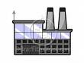](http://images.google.com.tr/imgres?imgurl=http://www.bradfitzpatrick.com/stock_illustration/images-new/household/cartoon-factory-clipart.gif&imgrefurl=http://www.bradfitzpatrick.com/stock_illustration/cartoon-household-clipart/cartoon-factory-clipart.htm&usg=__S3dayhCvHCtadevAMK-w2scJlm8=&h=180&w=240&sz=11&hl=tr&start=6&um=1&tbnid=AJE4VkPsz3O1WM:&tbnh=83&tbnw=110&prev=/images%3Fq%3Dbuilding%2Bclipart%26hl%3Dtr%26um%3D1) [](http://images.google.com.tr/imgres?imgurl=http://www.clipart-fr.com/data/clipart/voiture/voiture_031.gif&imgrefurl=http://www.clipart-fr.com/clipart.php?mot=ferrari&usg=__XqSCwsVaTGRxE4TuvqBpVFXSZmI=&h=242&w=490&sz=23&hl=tr&start=5&um=1&tbnid=G_1guRxOG3Z9fM:&tbnh=64&tbnw=130&prev=/images?q=ferrari+clipart&hl=tr&um=1) 

**1.**……………………………………………………..…..

**2.**………………………………………………………….

**3.**………………………………………………………….

**4.**………………………………………………………….

5………………………………………………………….

**F) Choose the correct answers. (Doğru olan şıkkı seçiniz) (3x16=48) +question 8 *2 =50**

9-

**1.** A: _ 1**)________ have you known Mary ?**

**B:For more than five years.**

**a)** When **b)** How long

**c)** How often **d)** What time

**2. Mary: Since I woke up at six o’clock. I’ve done the washin washing ,done the washing-up and vacuumed the floor. But But I haven’t done the ironing and the cooking yet.**

**Which sentence is true ?**

A. Mary hasn’t done the washing yet.

B. Mary was sleeping at six o’clock.

C. Mary has vacuumed the floor.

D. Mary has already done the ironing.

**3. The radio presenter: What would you like to advice the teenagers about acne?**

**The dermatologist: First, they should see a dermatologist. ………………. Second, they should drink two litres of water a day**

A. They should use chemical products.

B. They should eat junk food.

C. They mustn’t eat fresh fruit and vegetables.

D. They mustn’t try products by themselves.

**4-**

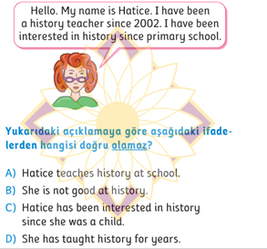

**5-** **Parçanın akışını bozan cümleyi bulunuz**

**I-**Einstein was a scientist.

II- He established the formula MC2

III-His father wasn’t a religious man.

IV- With his invention he won the Nobel Prize.

V-Then he became very famous.

**V b. IV c. III d. II**

6- **I’m afraid I can’t pass this exam. The questions………………….to answer.**

a) are too easy b) are too difficult

c ) aren’t difficult too d) are easy too****

**8- Asil: I am ill.**

**Baran: Me-----------**

a) too b) either c) neither d) not

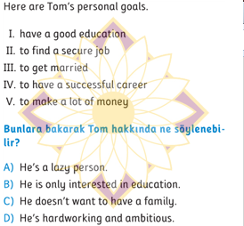

**10-** Susan: Can you help me with the washing-up?

John: I’m sorry, I can’t. I’m watching TV now.

Susan:________________________.

a) You’re welcome b) It’s not fair!

c) It’s a good idea! d) Wow,, great!

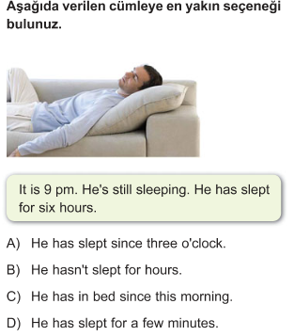

12- **Teacher: Why did Atatürk declare the Amasya Circular? Student: Because _______________________ so that Turkish people could defend their homeland all together.**

A) he wanted to modernize the country

B) he could fight the enemy on his own as well

C) he was sure that Turks would lose the war

D) he wanted to unite people against the enemy

**13- “job security” means**

|  |
| --- |
| **A)** You still have your salary when you’re ill |
| **B)** You have rights to keep your job. |
| **C)** You have your own office. |
| **D)** You have a good employer. |

**14-“scholarship” means…**

a)improvement,development b)advisor at a school

c)money for school expenses d)discuss

15-What does **“sick pay”** mean?

a) have salary when you’re ill b) have you are on holiday

c) good colleagues d) job security

16- **Pınar :Have you ever ________ in your life?**

**İrem : Yes,I went on safari in Africa last year.They are really big animals.**

a) done puzzles b) been to a historical city

c) seen an elephant d) seen a celebrity?

17- **Bahar : Let’s go to the concert, dad!**

**Father : ____________**

**Bahar : Why?**

**Father : I have an important meeting.**

**a) That is a good idea b) yes, of course**

**c) I am afraid I can’t d) Luck of you**

11

7