A. Aşağıdaki boşlukları verilen kelimelerle doldurunuz.
- Does
- Where
- fishing
- What
- painting
1. I like ………………………
2. ……………… are your hobbies?
3. …………… he like playing golf?
4. She ……………. Painting.
5. …………… do you like going?

B. Aşağıdaki tabloya göre cümleler doğru ise yanlarına True, yanlış ise False yazınız.
 |  | 
Jane | 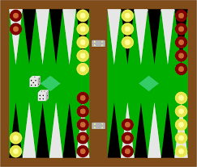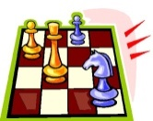 | 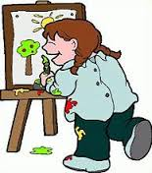
Ian | 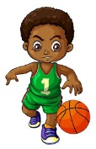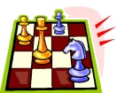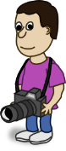 | 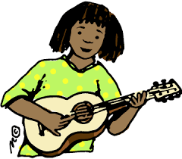
Gina
Gary
Liam

1. Gary and Liam like playing the guitar. ………..
2. Ian and Liam like playing basketball. ……….
3. Ian and Gina don’t like playing the guitar. ……….
4. Jane, Ian and Gina like playing chess, but Gary doesn’t. ……………
5. Jane likes painting, but Gina doesn’t. …………..
6. Liam doesn’t like taking photos, but Gary does. ……………..
7. Jane, Ian and Liam like playing backgammon. …………….
8. Gary and Liam like playing basketball, but Ian doesn’t. ………………
9. Ian and Gina don’t like playing the guitar, but Gary and Liam do. ……………….
10. Liam and Gary like taking photos. ……………..

C. Aşağıdaki paragrafı okuyunuz ve kişilerin hobilerine göre isimleri ile resimleri eşleştiriniz.
Karen likes doing origami, but she doesn’t like painting. Sheila likes painting but she hates doing origami. Uncle Jack dislikes playing golf but he loves fishing. Ralph likes knitting but he hates chess. John likes taking photos. Josh hates bowling but he likes playing chess. Fred loves horseback riding but he hates taking photos.
1. Uncle Jack A. 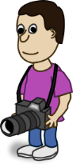
2. Sheila B. 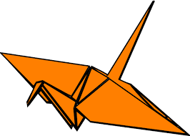
3. Karen C.
4. Josh D. 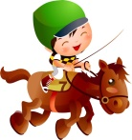
5. John E. 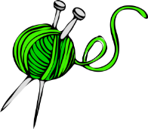
6. Fred F. 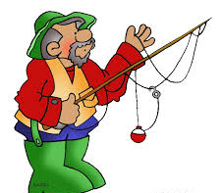
7. Ralph G. 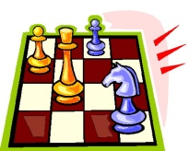

D. Aşağıda harfleri karışık olarak verilmiş kelimeleri düzenleyiniz.
1. ooicgnk:
2. lpygani ogfl:
3. hsces:
4. hceksrce:
5. onbgilw:

CEVAP ANAHTARI
A BÖLÜMÜ
1 fishing
2 What
3 Does
4 painting
5 Where

B BÖLÜMÜ
True – 1-3-4-6-9
False – 2-5-7-8-10

C BÖLÜMÜ
1F
2C
3B
4G
5A
6D
7E

D BÖLÜMÜ
1 cooking
2 playing golf
3 chess
4 checkers
5 bowling

