A. Boşlukları verilen kelimeler ile doldurunuz.
- broken leg
- a high fever
- take a painkiller
- scratch
- toothache
1. When you have a headache, you should …………………………………
2. When you have ………………………, you should stay in bed and have a rest.
3. When you have a …………………………, you should go to a dentist.
4. I have a ………………………….., I can’t walk.
5. When you have a bug bite, you shouldn’t …………………… it.

B. Aşağıdaki cümleleri görsellerle eşleştiriniz.
1. You should go to a dentist. A. 
2. You should stay in bed. B. 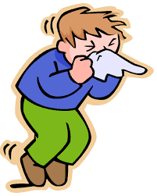
3. You should drink lemon and mint tea. C. 
4. You should blow your nose. D. 

C. Aşağıda verilen hastalıklarla uygun tavsiye cümlelerini eşleştiriniz.
1. I have a terrible headache A. She shouldn’t scratch it.
2. My arm is bleeding B. You should go to a doctor.
3. My cat has the flu C. You should apply a band-aid on it.
4. My sister has the measles D. He should go to a dentist.
5. Eric has a toothache E. She should stay at home.
6. Tina has a bug bite F. You should take it to a vet.
D. Aşağıdaki kelimeleri görsellerle eşleştiriniz.
1. Chicken pox A. 
2. Headache B. 
3. Backache C. 
4. Runny nose D. 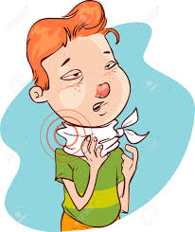
5. Stomachache E. 
6. Bug bite F. 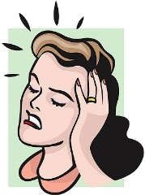
7. Sore throat G. 

CEVAP ANAHTARI
A BÖLÜMÜ
1 take a painkiller
2 a high fever
3 toothache
4 broken leg
5 scratch
B BÖLÜMÜ
1D
2A
3C
4B
C BÖLÜMÜ
1B
2C
3F
4E
5D
6A
D BÖLÜMÜ
1C
2F
3B
4A
5G
6E
7D

