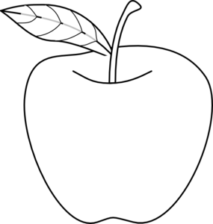
www.egitimhane.com

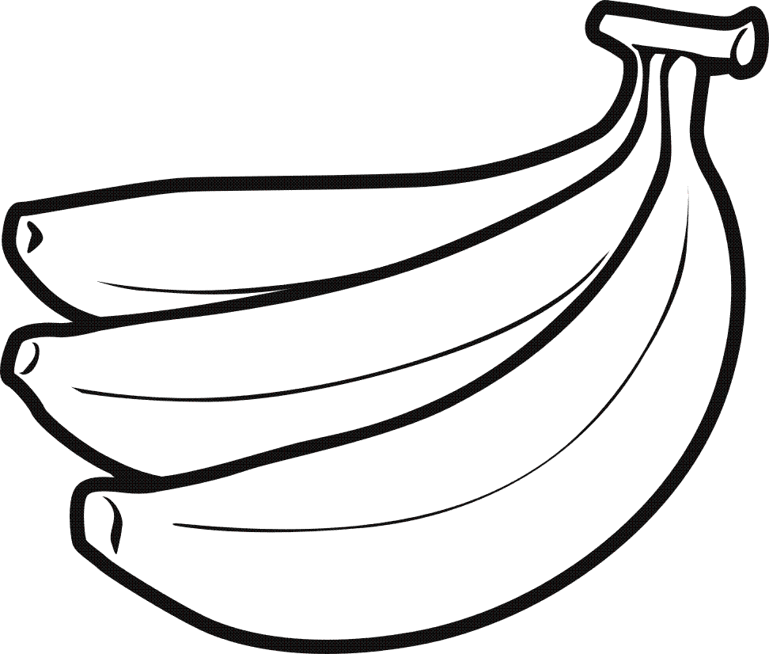
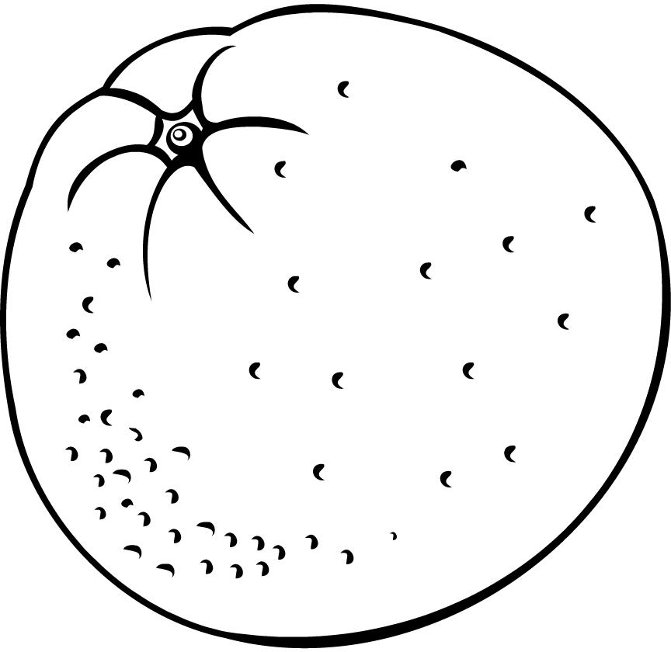
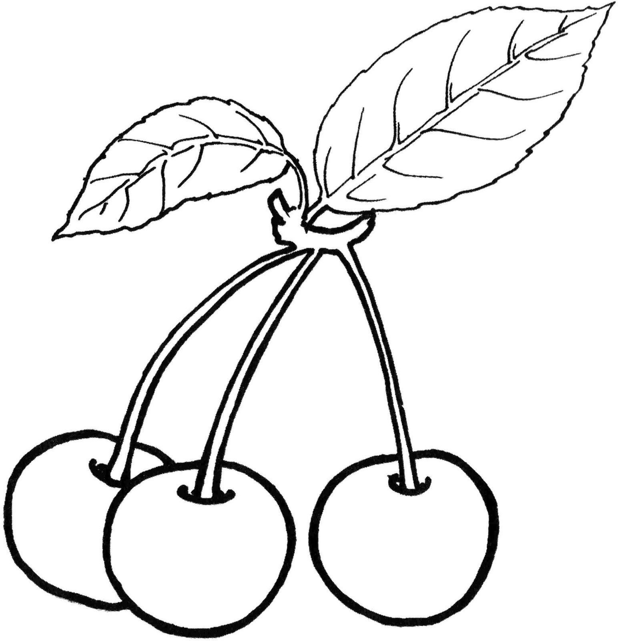
Apple : elma
____________________________________________
____________________________________________
____________________________________________
____________________________________________
____________________________________________

Banana : muz
____________________________________________
____________________________________________
____________________________________________
____________________________________________
____________________________________________

Orange : portakal
____________________________________________
____________________________________________
____________________________________________
____________________________________________
____________________________________________

Cherry : kiraz
____________________________________________
____________________________________________
____________________________________________
____________________________________________
____________________________________________
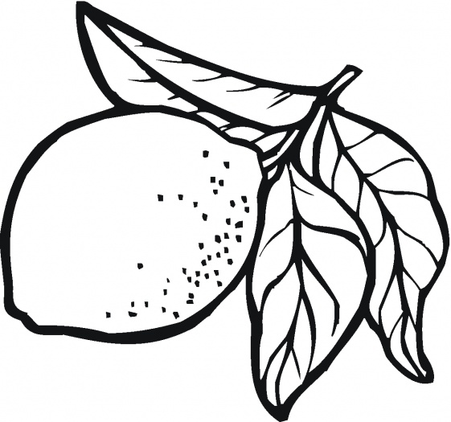
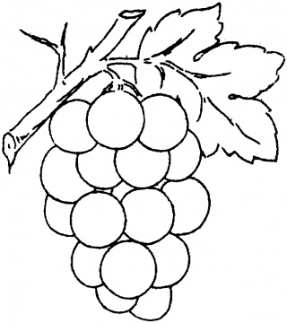
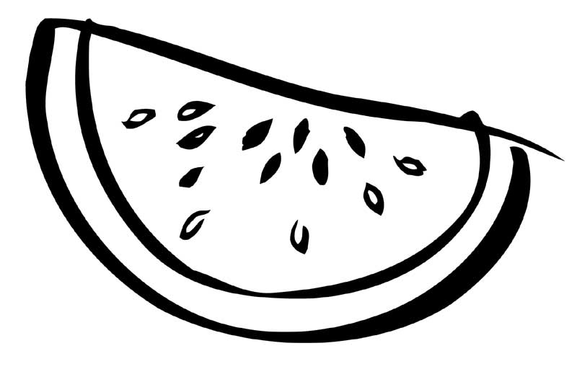

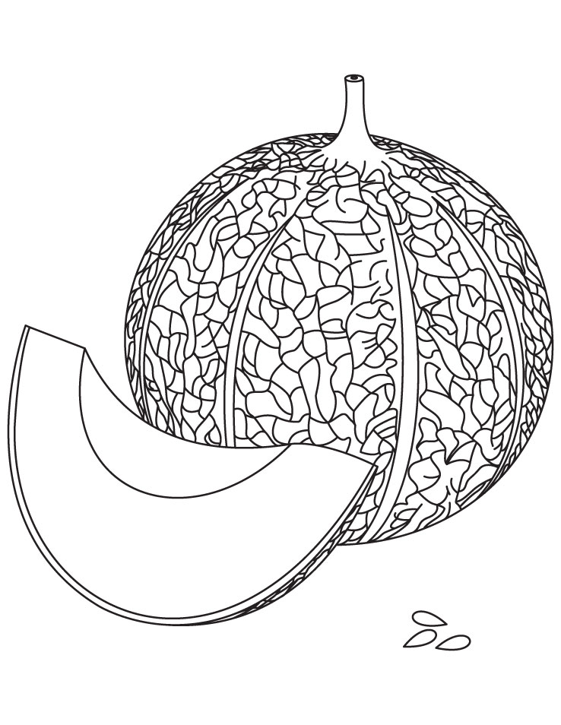
Lemon : limon
____________________________________________
____________________________________________
____________________________________________
____________________________________________
____________________________________________

Grape :üzüm
____________________________________________
____________________________________________
____________________________________________
____________________________________________
____________________________________________

Watermelon : karpuz
____________________________________________
____________________________________________
____________________________________________
____________________________________________
____________________________________________

melon : kavun
____________________________________________
____________________________________________
____________________________________________
____________________________________________
____________________________________________
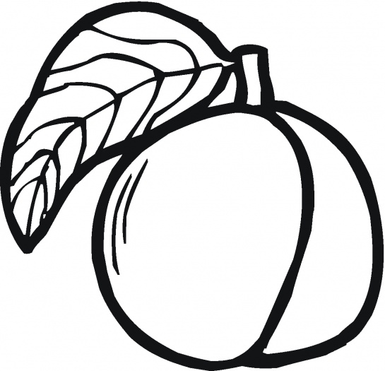
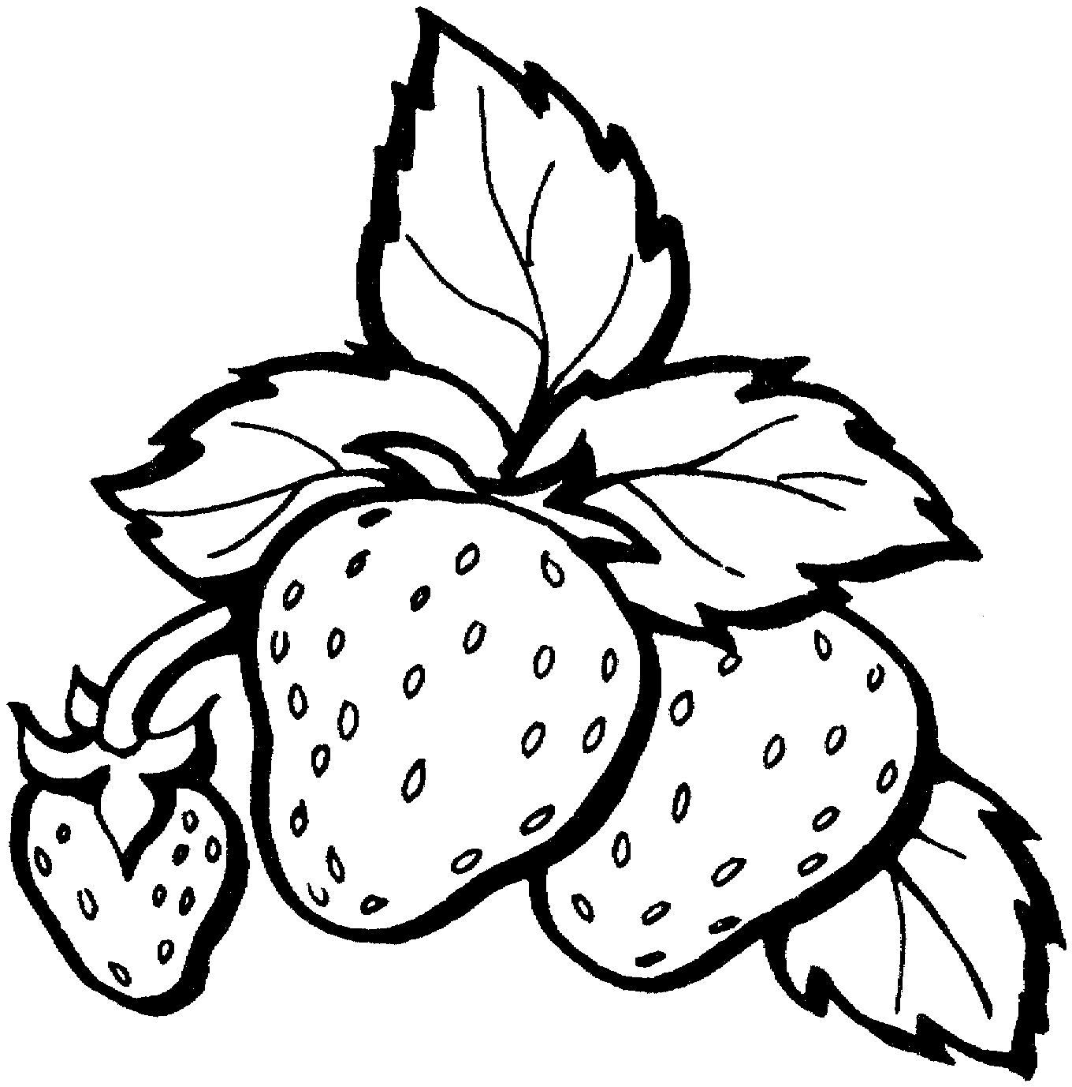
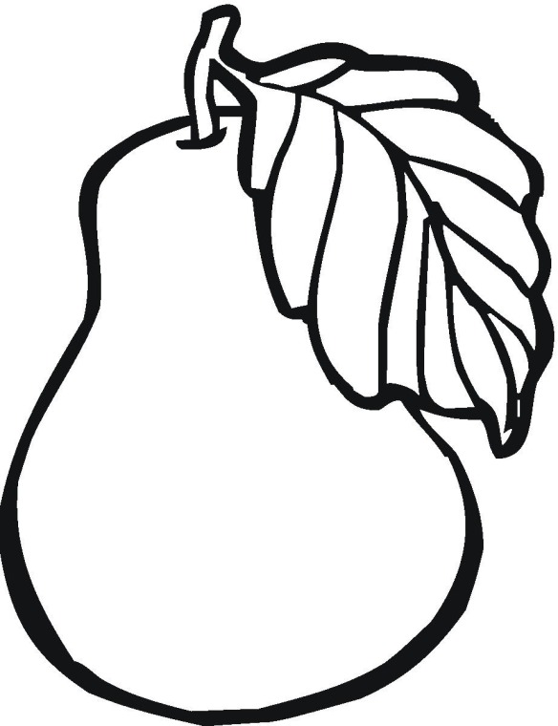

Peach : şeftali
____________________________________________
____________________________________________
____________________________________________
____________________________________________
____________________________________________

Strawberry : çilek
____________________________________________
____________________________________________
____________________________________________
____________________________________________
____________________________________________

Pear: armut
____________________________________________
____________________________________________
____________________________________________
____________________________________________
____________________________________________

