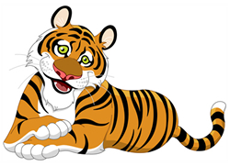

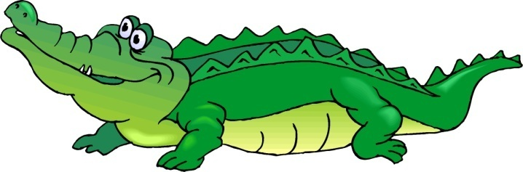

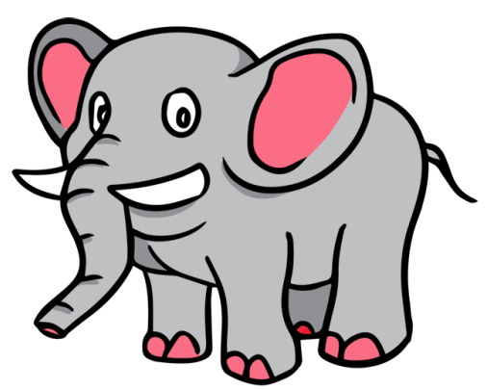

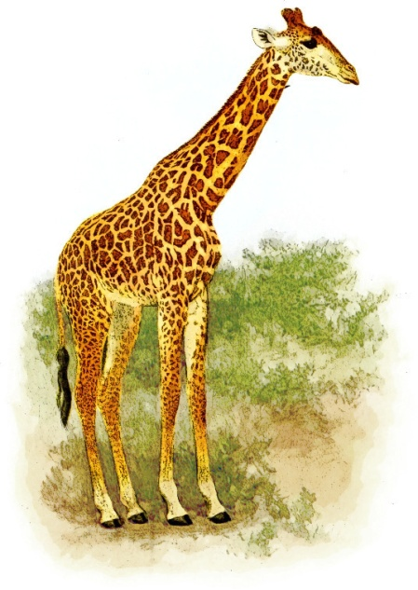
tiger: kaplan
____________________________________________
____________________________________________
____________________________________________
____________________________________________
____________________________________________

crocodile: timsah
____________________________________________
____________________________________________
____________________________________________
____________________________________________
____________________________________________

elephant: fil
____________________________________________
____________________________________________
____________________________________________
____________________________________________
____________________________________________

giraffe: zürafa
____________________________________________
____________________________________________
____________________________________________
____________________________________________
________www.Egitimhane.com____________________________________
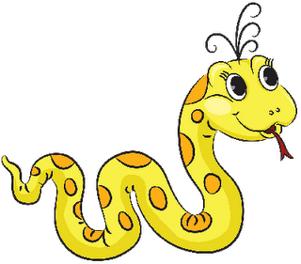

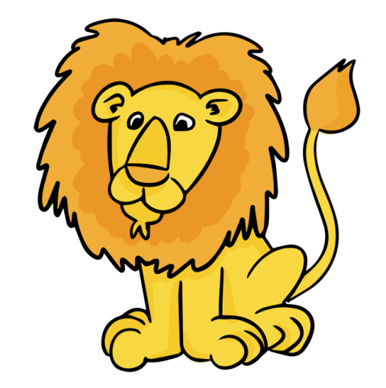

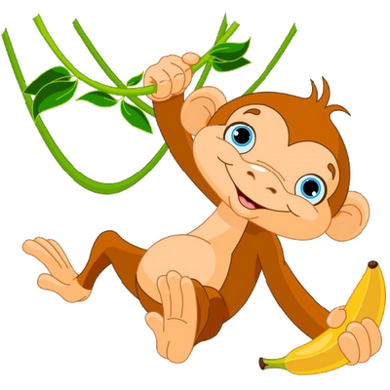

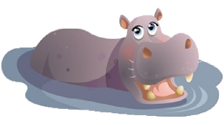
snake: yılan
____________________________________________
____________________________________________
____________________________________________
____________________________________________
____________________________________________

lion: aslan
____________________________________________
____________________________________________
____________________________________________
____________________________________________
____________________________________________

monkey: maymun
____________________________________________
____________________________________________
____________________________________________
____________________________________________
____________________________________________

hippo: su aygırı
____________________________________________
____________________________________________
____________________________________________
____________________________________________
____________________________________________

